**(27) Waves, Tides**

Tides:

1. Tides refers to vertical movement of water nearly each place on the earth experiences two high tide tow low tide
2. Reasons for formation of tides are gravitational pull of sun, gravitational pull of moon and the centrifugal force of earth as counter force to gravitational pull of sun and moon.
3. The gravitational pull of moon plays an important role because of its nearness to earth.

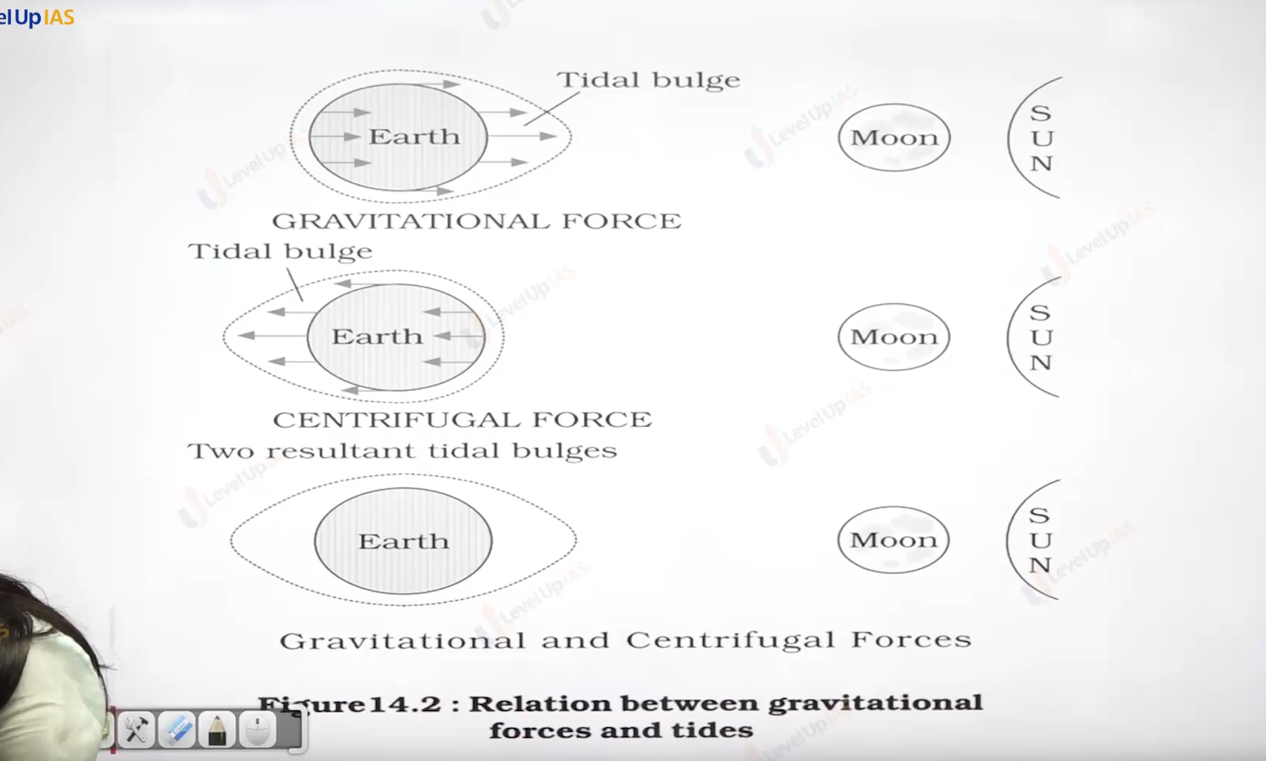

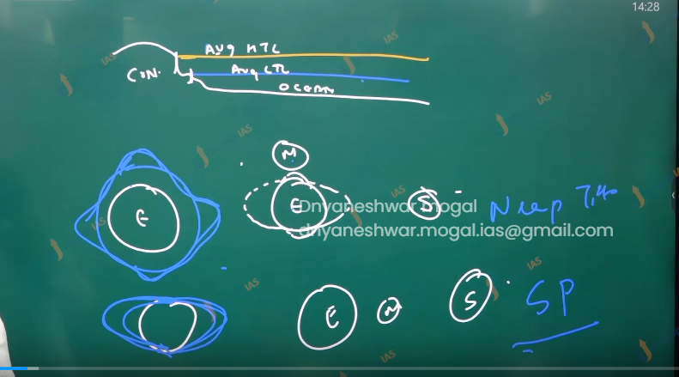

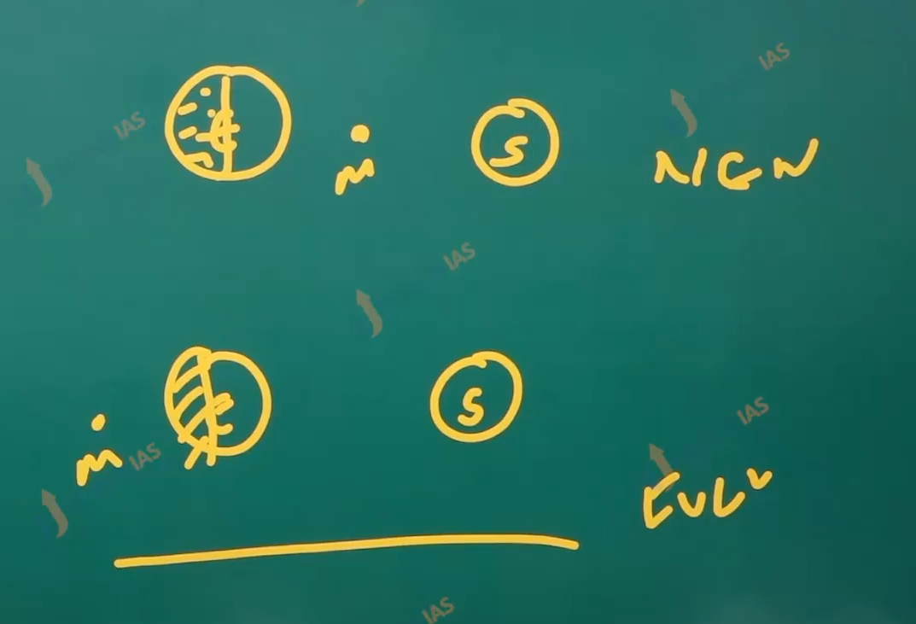

Type of tide

1. Basis of sun and moon:
   1. The position of sun and moon are in straight line. At this position the height of high tides is above the average high tide level. And
   2. The low tides are quite below the average low tide level. Therefore, the difference between high tide and low tide is very high.
   3. They occur 2 in the month once full moon day and new moon day.

Neap type:

1. Normally there is 7 days interval between spring and neap type.
2. Here in the neap type the sun, earth and moon are at a right angle to each other.
3. The forces of sun and moon tend to counter acts one another the moon attractions Tho more than twice as strong as that of suns is diminished by the counter acting force of sun gravitational pull.

Importance of tide.

1. It helps navigator and fisher man.
2. Tidal energy can be utilized to supplement the present energy mixed.
3. Tidal plants in the gulf of combat, gulf of Kutch, Andaman Nicobar Island, Durgaduani in Sundarbans.
4. Tides also help in desiltation along the coast.

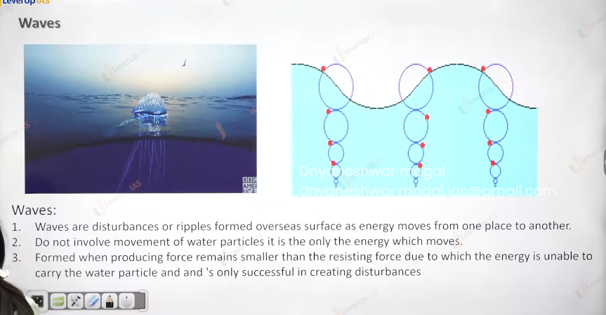

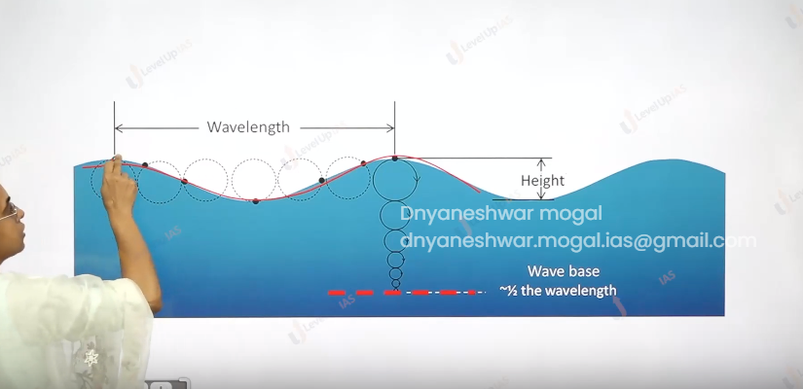

Waves:

1. Waves are disturbances or ripples on the ocean surface as energy moves from one place to another.
2. It formed when the energy producing source is smaller than the resisting force due to which energy is unable to carry the water particles and it Is successful in only creating the disturbance.
3. In waves it is energy that moves not the water as such which moves across ocean surface.
4. Water in the wave moves in the circular manner / small circular as the wave passes As long as waves base is half of wavelength the wave maintains its shape but as soon coast appears the wave starts breaking.

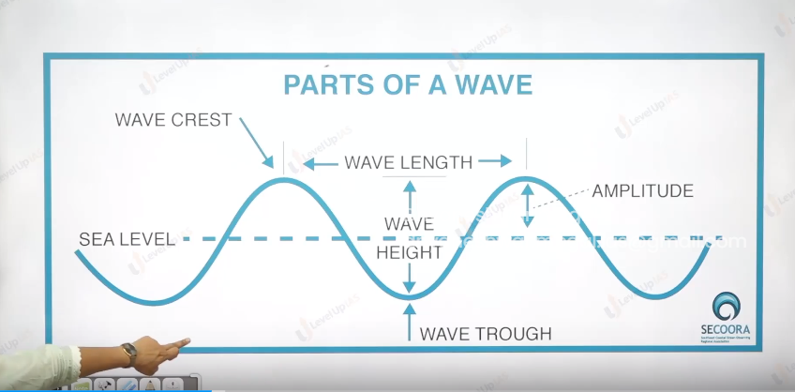

Parts of waves:

1. The wave can maintain it shape as long as the depth is half of wavelength or greater than half the wavelength.
2. On approaching the coast, the wave breaks as depth of ocean floor are become less than the half of wavelength of wave.

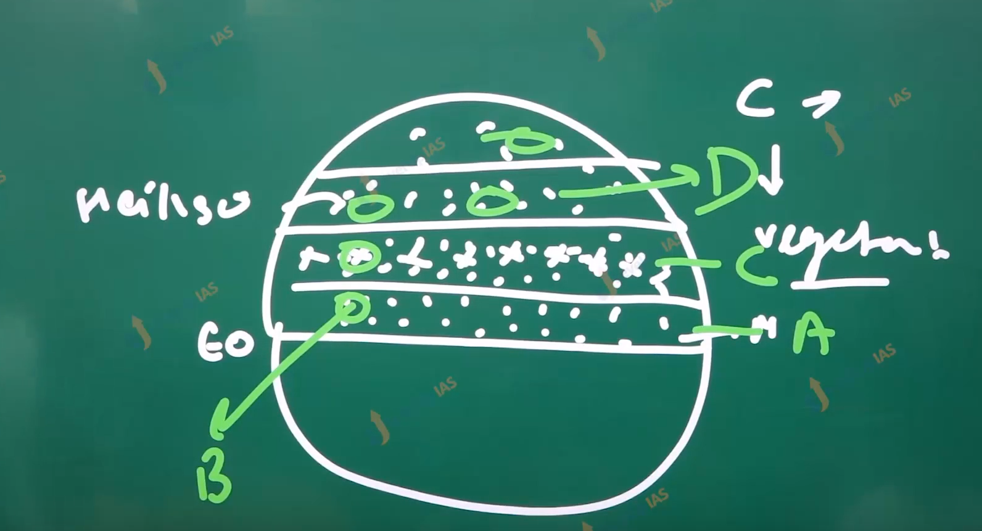

World and climate and climate change:

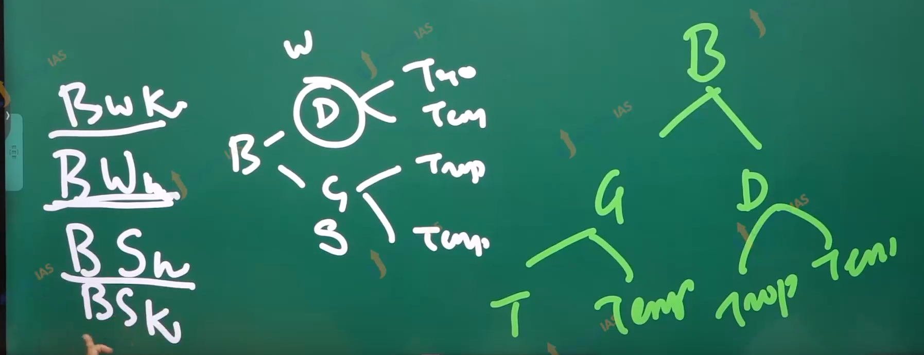

Later given to the weather pattern in the world.

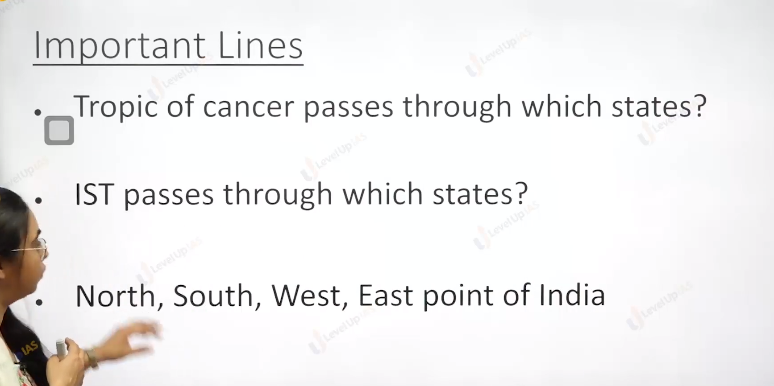

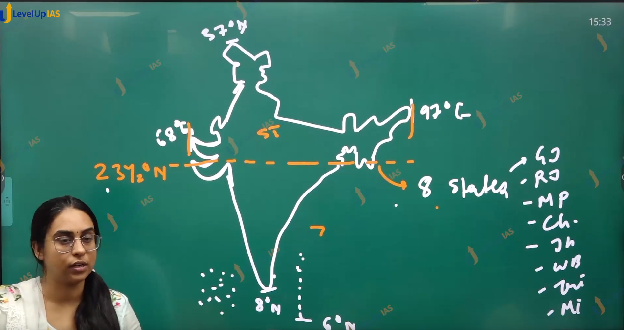

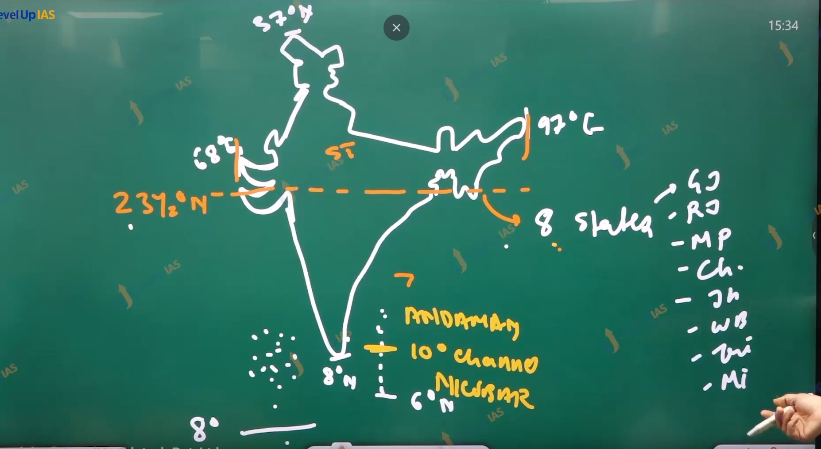

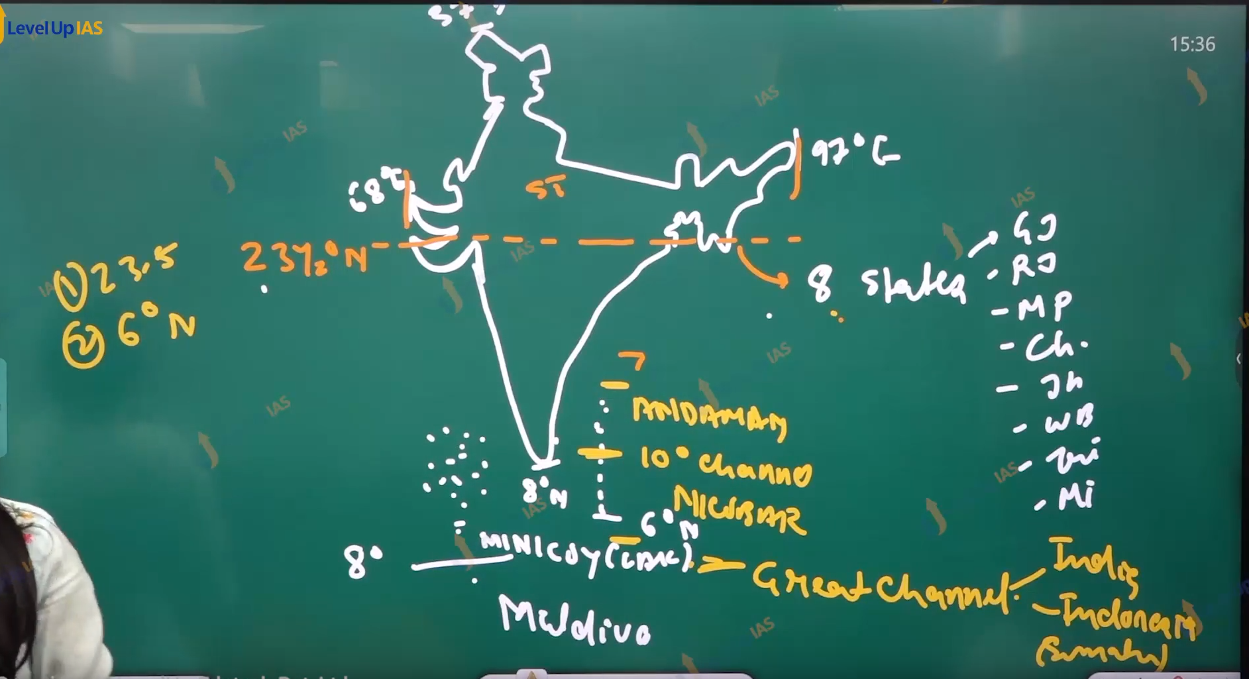

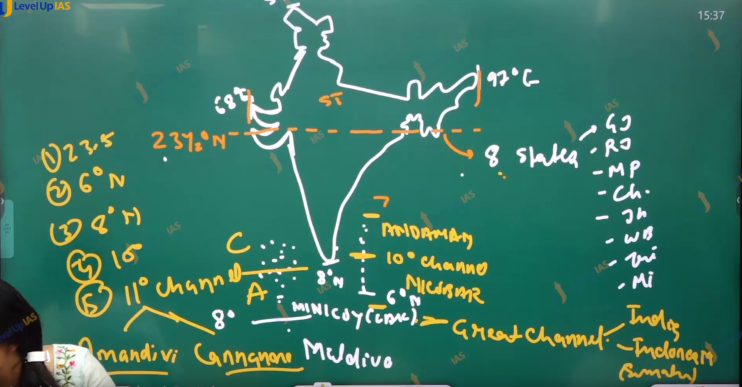

Amindivi and Cannanore.

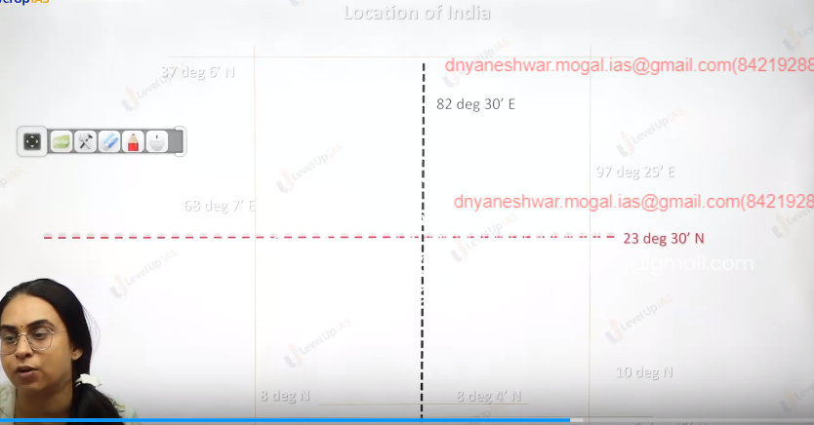

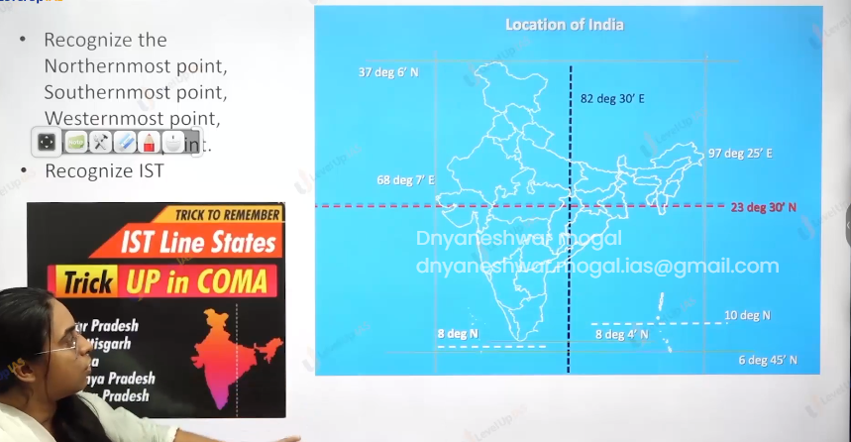

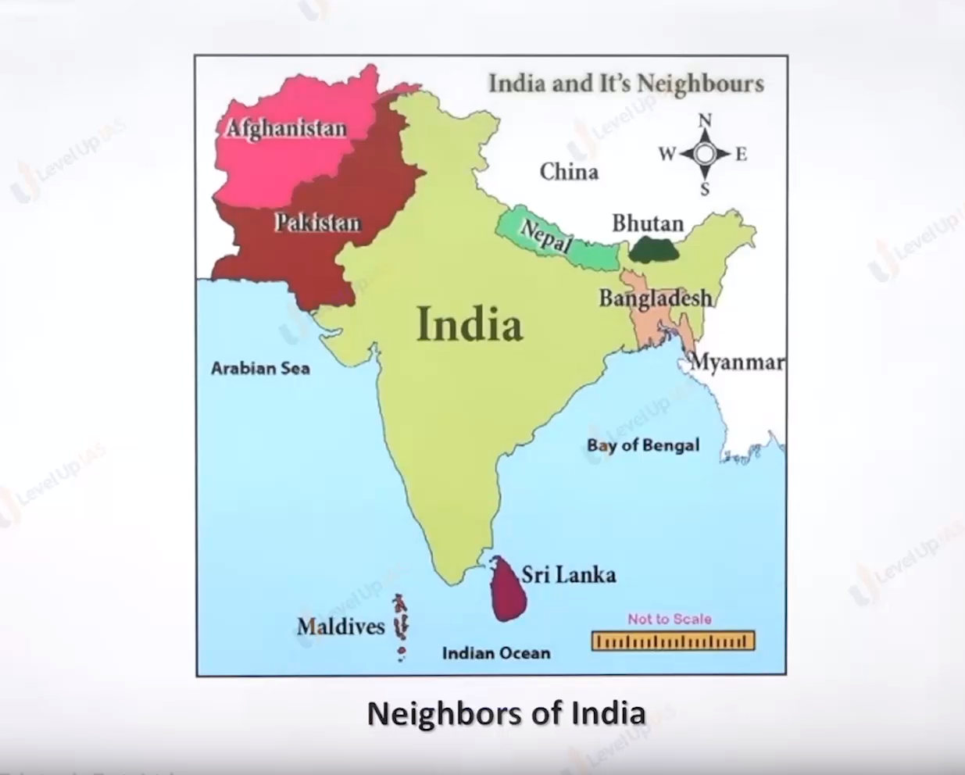

Facts about India’s geography

1. India is 7th largest country in the world. India as 2.4% of the world’s land and 17% of the world's population.
2. 17% of the world’s livestock. And 4 % water resources.
3. IST fallows 82 deg 30’ E it passes through 23 deg 30’N
4. Nabours are Bangladesh, China, Pakistan, Nepal, Myanmar, Bhutan, Afghanistan.
5. Country size wise.RCCUBAI RASSIA CHANADA, Chaina Brazil austrialia and india.

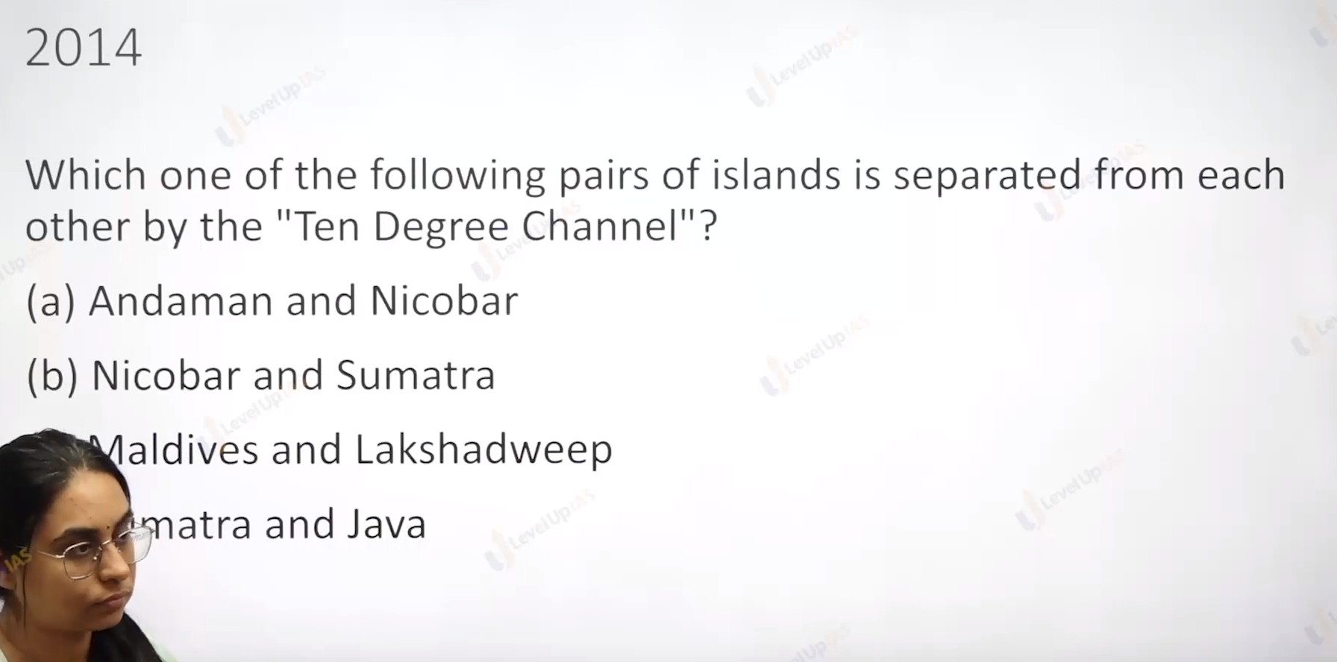

Answer is a

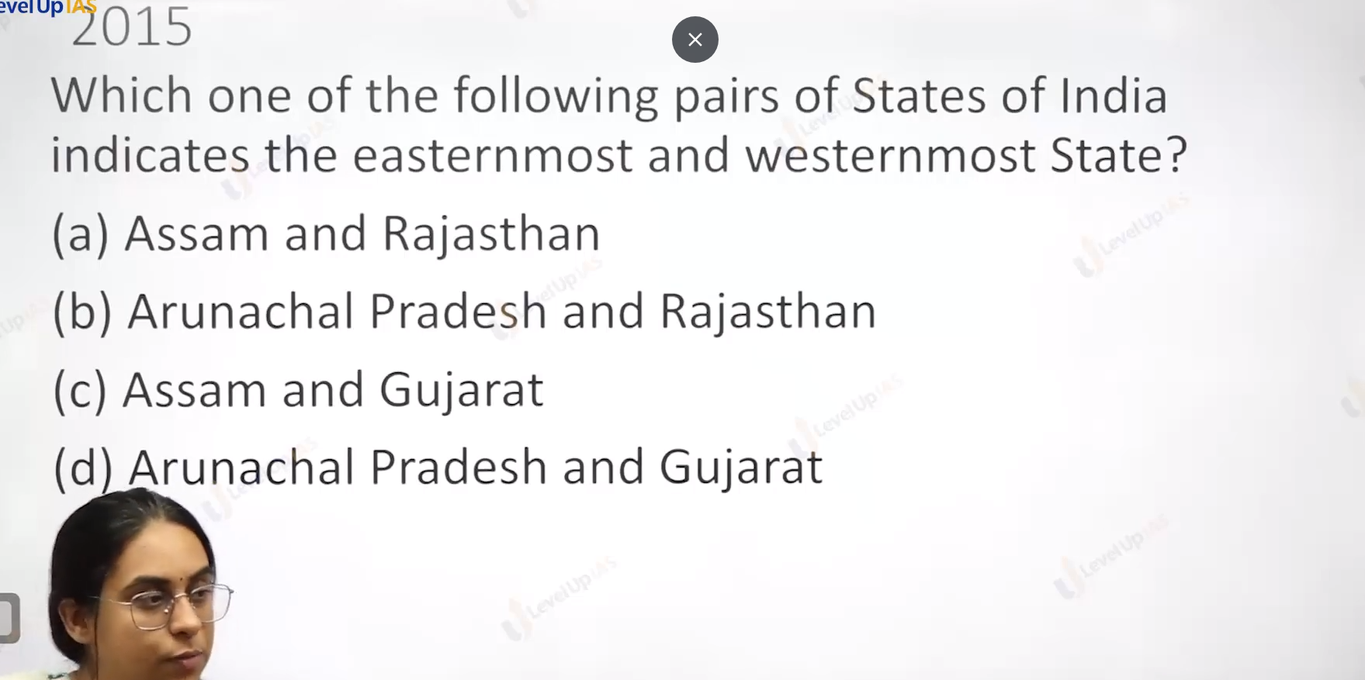



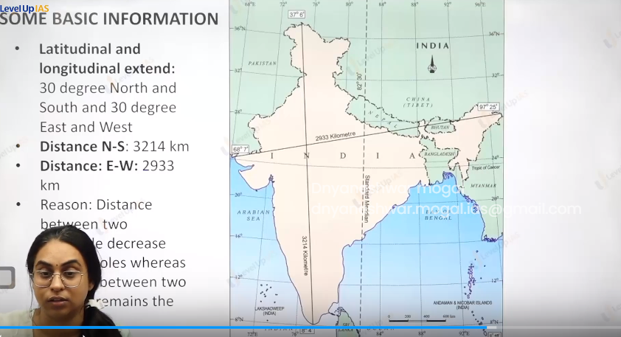

Some basic information’s

1. Latitudaanal and longitudinal extents is 30 degrees. The north south extents are more 3214 where east western 2933 this is because the distance between two longitude is degree towards the pole whereas distance between the two latitudes

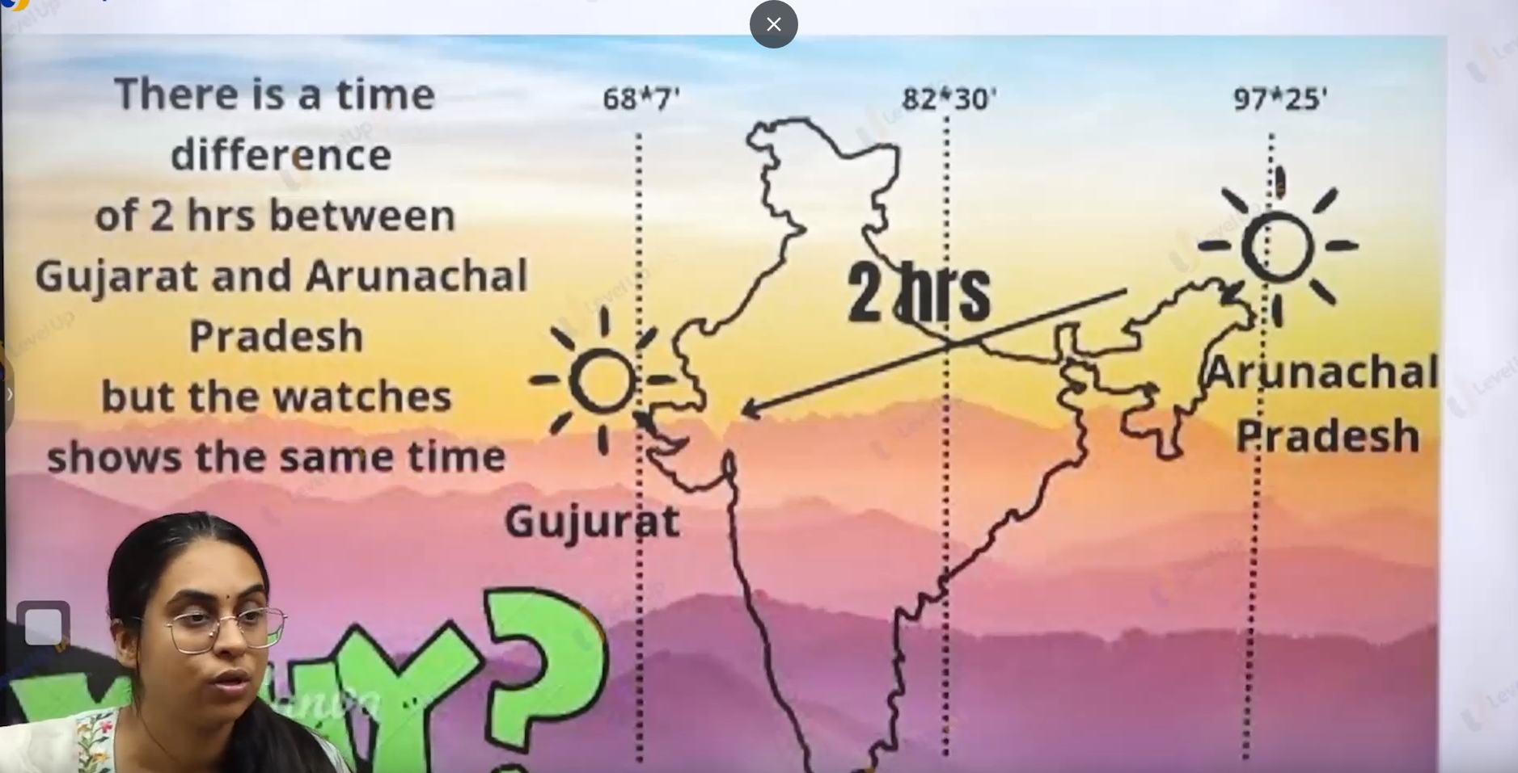

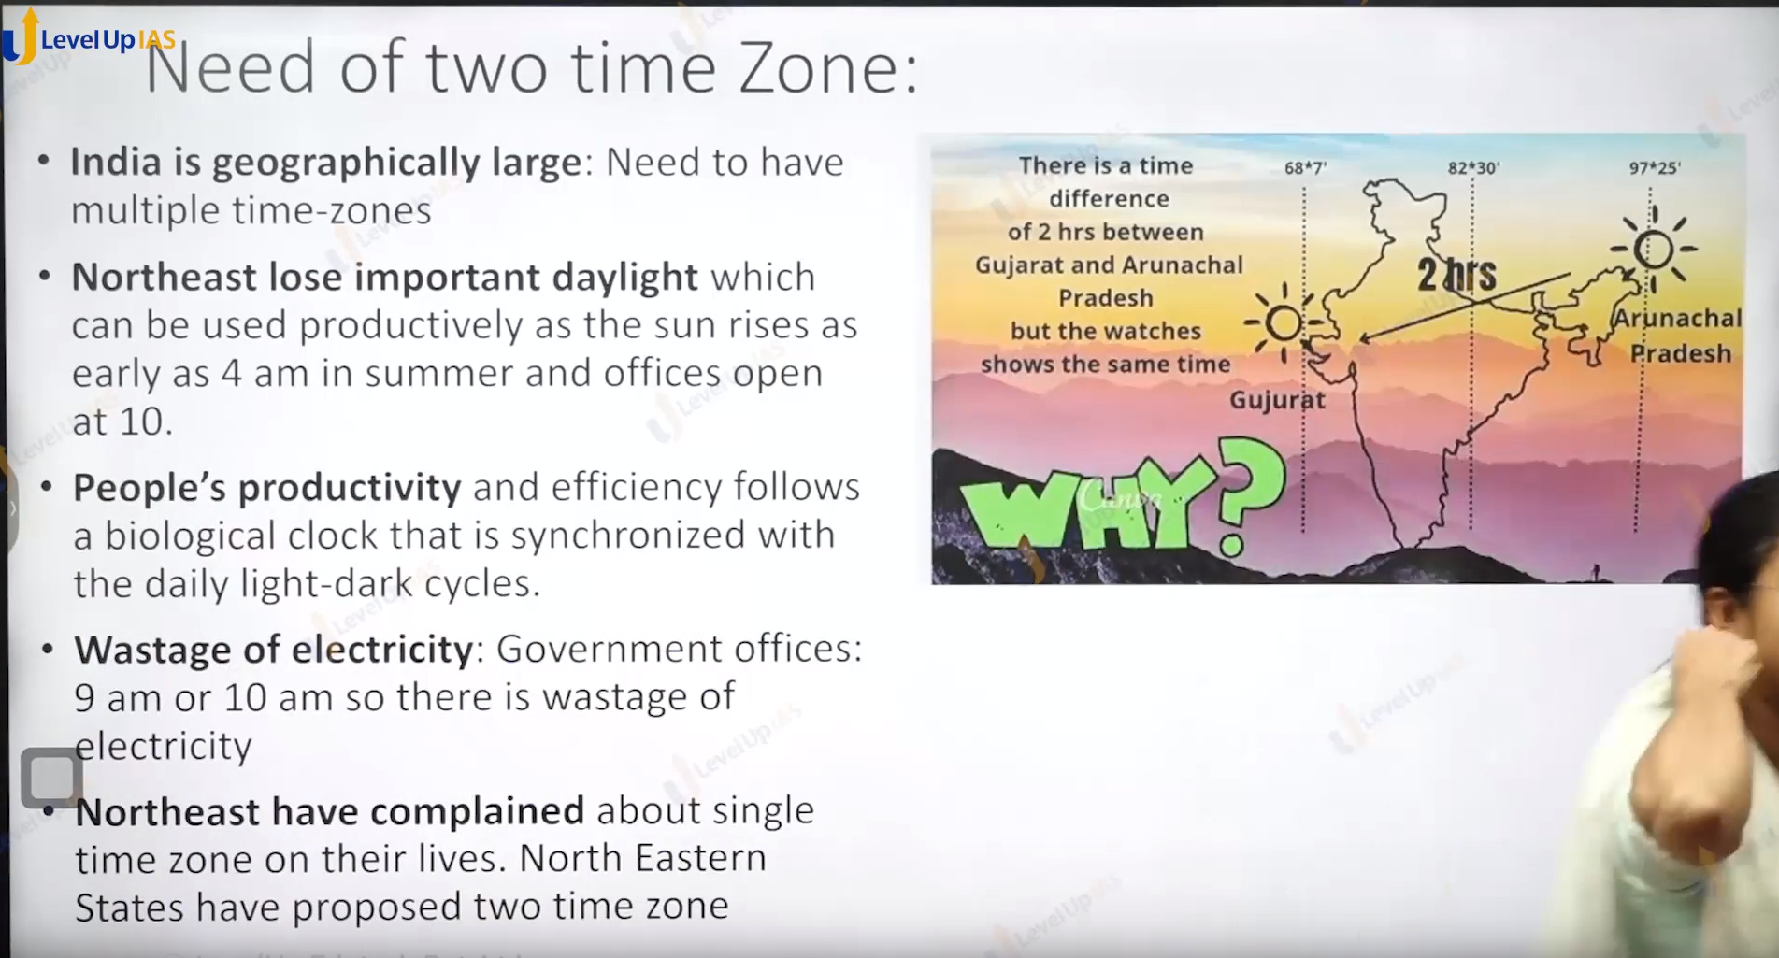

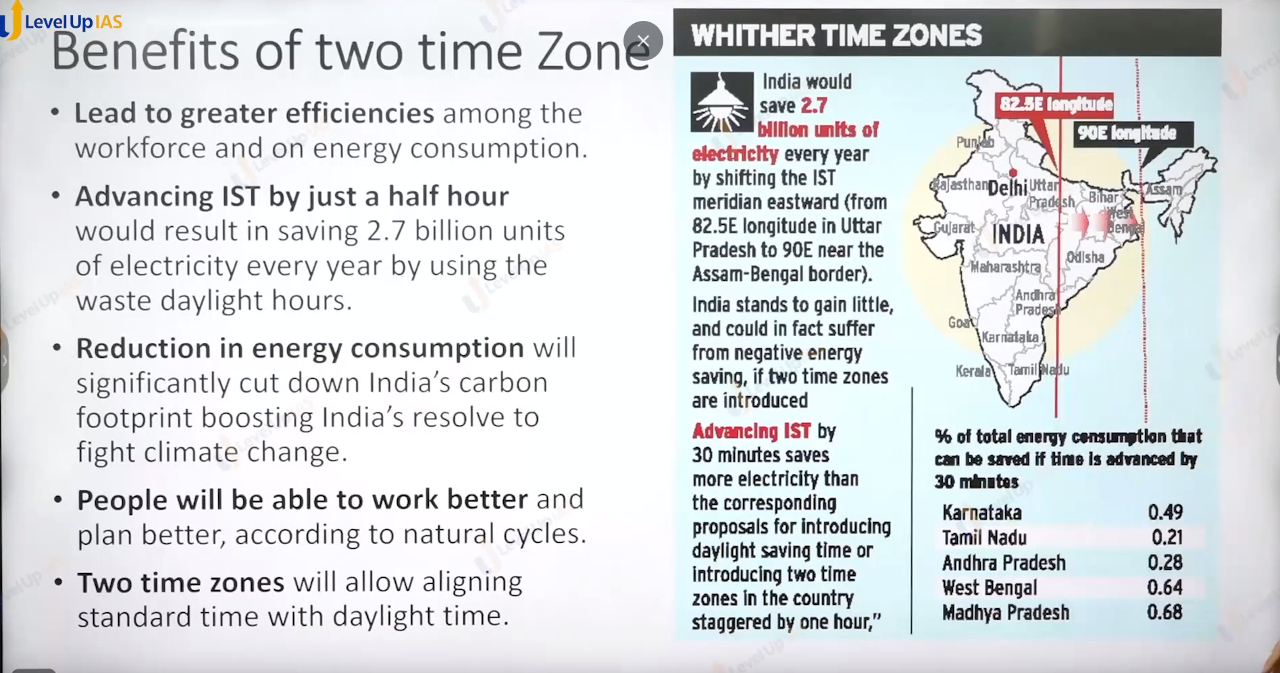

4 state that share the border with Myanmar Arunachal Pradesh, Nagaland Manipur and Mizoram.

Find out the state that share border with Pakistan China and Nepal. Bangladesh Bhutan.

Pakistan: Jammu and Kashmir, Rajasthan, Panjab, Gujrat.

Nepal: Uttarakhand, Utter Pradesh, Bihar, West Bengal, Sikkim.

China: Ladakh, Himachal Pradesh, Uttarakhand, Sikkim, Arunachal Pradesh.

Bangladesh: Assam, West Bengal, Mizoram, Meghalaya, and Tripura.

Bhutan: Assam, Arunachal Pradesh, Sikkim, and West Bengal.